Mars Dashboard Handover
Server: solwww.oma.be
Location on server: /var/www/ssa/htdocs/sscc/DashboardMars/

Scope
The Mars Dashboard is a collection of data specifically collected to be useful for Mars missions. It is, in first place, built from data available on the ssa portal although some products are replaced by easier means or some products added.

The project

overview
The project is available on GitLab SSCCdashboardMars under the source/WEB folder (in analogy with the other ssa projects). This folder contains the following folders:
- Classes
Contains handler classes for parts of the website
- InfoText
text files that contain information text and are read by the webpage while loading.
- Nbproject
A folder from netbeans, not necessary for deployment
- Scripts
all client side scripting
- Settings
Settings used by the page on load.
- Styles
Stylesheets for the page, also includes images
And the files
- Dm.php
builds the actual page.
- Index.html
root page that is initially loaded. Loads some images behind the portal first, then automatically redirects to the dm.php page.
To install the new version on the server, simply copy this entire folder (files and folders) to the server, nbproject excluded.

Basic scheme

The code uses (mainly) javascript to access information from the SSA sources. This is because, although the server itself is behind ESA’s SSO, it does not hold the cookies (containing access information) from the users.
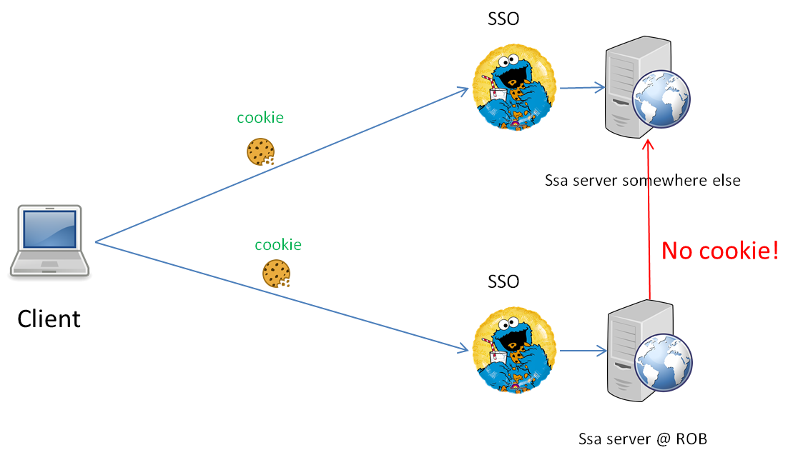
The SSO poses an additional problem where an HTML img tag can only load pure image URL’s. On first access the image URL is redirected to request the cookie on the SSO. This redirect is not a pure image URL and loading the image fails. In order to fix this, the image URL is first loaded in an HTML object tag. This element is capable of loading throughout the redirection phase. Since the object element cannot rescale the image, the image is first loaded through the object element, after which the redirection behind the scenes is done. Then the image is loaded in a proper image tag.

Loading the page
When a user request the dashboard, (s)he does so by browsing to http://ssa.sidc.be/sscc/DashboardMars/ and passing his/hers access credentials. The user automatically lands on the index.html page.
This index.html page loads images behind the SSO invisibly and when done redirects to the dm.php page that actually builds the content. The dm.php is a form of a “skeleton page” that fills in the content dynamically with necessary information. It uses the Common.php, SEU.php and Charging.php classes in the Classes folder, that each build part of the webpage. (in this case they each build a tab).
Note that the classes only spit out “html” text (and also javascript, css, …). This text is sent to the client computer, where the browser takes care of the rest. This is necessary so the client can access API calls to server behind the SSO.
